United Way of Greater Plymouth County Brand Guidelines & Logo Kit
October 2015
Logos for Print Use (brochures, annual reports, letterhead, etc.)

Logos for Screen Use (website, PowerPoints, cell phones, etc.)
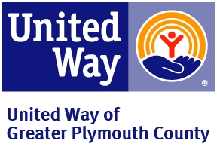

Special Use Logos
ONE-COLOR
When reproduction constraints prevent the use of the primary full-color United Way brandmark, use one of the
alternative one-color versions below. The white control box is still present in these one color
solutions.
One-color blue brandmark
The one-color blue brandmark is to be used when United Way Blue is the only available color selection.
One-color black brandmark
The one-color black brandmark is to be used when black is the only available color selection.

Special Usage Logos
This would apply, for example, when reproducing on fabric, plastic, glass or other materials used for
merchandise or signage.

