United Way of Greater Plymouth County
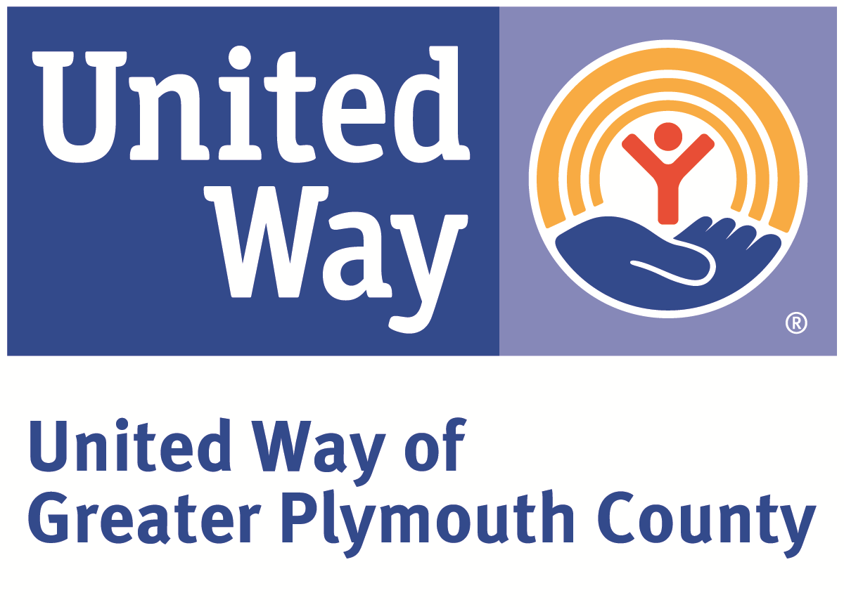
Funded Community Partner Compliance Agreement

United Way has partnership compliance, co-branding, and fundraising standards and policies intended to both provide mutual marketing benefits and to fully support the annual fundraising campaign. Organizations receiving United Way of Greater Plymouth County funding are required to perform the following:

- Co-Branding Requirements
- Signage (Signs and decals supplied by United Way)
Visibly display United Way provided signage as appropriate to your building/office space.
- Logo Usage (electronic logos supplied by United Way)
Include a 1-color, full color or black & white United Way Partner Agency logo and/or text line reading “A United Way Partner Agency” on: agency/program newsletters, brochures for United Way-funded programs, annual reports, agency/program letterhead, & agency event invitations and programs
- Website
Identify United Way partnership with UWGPC logo and provide a link to www.uwgpc.org.
- Other creative co-branding activities are encouraged and appreciated such as United Way logo on clothing items (activity/event t-shirts as appropriate), vehicle decals, phone greetings, etc.

- Reporting Requirements
- Year End Reports & Success Stories
Complete and submit a Year End Report for each funded initiative. (Report will be supplied to all agencies at the end of each funding cycle.) Please report succinctly on the intended outcomes of your proposal. Please also be prepared to provide the following information on your Year End Report: actual initiative revenues and expenses; number served by city/town; age of those served; gender of those served; race & ethnicity of those served; and income level of those served.
- Submit annually a minimum of one client/program success story per Initiative, which is tied to results your agency is achieving in support of the Community Impact Initiative.

- Partnership Events & Activities Requirements
- Consistently send a representative to United Way Agency Executives meetings.
- Participate in Agency Exhibition at United Way Annual Meeting and send at least one representative to event.
- Attend Campaign Kickoff event and provide volunteer Day of Caring project(s).
- Upon request, provide speakers, displays and/or tours in support of the annual campaign or other efforts.
- Register with and utilize UWGPC Volunteer SouthCoast program for volunteer opportunities: www.volunteersouthcoast.org.
- Collaborate in media efforts/approaches.
- Mention United Way funding partnership in newspaper releases/media contact that relate
to programs/services/initiatives funded by United Way and in other releases/contacts as
appropriate. For example, use the sentence “___________a United Way partner agency is launching…”

- Employee Campaign & Fundraising Requirements
- United Way Employee Campaign: Actively solicit employees and, if possible, complete prior to community-wide campaign kickoff. All campaigns must be complete by the third Friday in November.
- Organizations funded by United Way are prohibited from conducting workplace campaigns to directly benefit their organization as workplace campaigns are the primary source of generating resources for United Way to benefit our community partners.
- Organizations receiving United Way funding shall not promote or encourage designations to own organizations.
- Applying for government grants and non-corporate foundation grants can take place at any time of the year.
Funded Community Partner Compliance Agreement

When United Way volunteers choose to invest in an organization’s services, they are doing so on behalf of all of our individual and corporate donors. United Way’s continued success in generating resources is dependent on our community partners accomplishing projected outcomes embodied in their proposals. United Way has partnership compliance, co-branding, and fundraising standards and policies intended to both provide mutual marketing benefits and to fully support the annual fundraising campaign. This fundraising campaign is United Way’s primary source of funds for investment in the services agency partners can provide.

The Funded Community Partner policies are in effect to guide our agency and community partners in their marketing and fundraising activities. Organizations that receive funding from United Way of Greater Plymouth County are expected to abide by and adhere to these policies. United Way will monitor them for compliance. Please be aware that failing to comply with these polices or failing to accomplish projected outcomes of initiatives may result in a reduction of or loss of United Way funding.

We are asking each agency involved in the Request for Proposal process in support of Community Impact to sign and submit this agreement as part of the RFP package.

Please sign and return this original, keeping a copy for your reference.

Our signatures below indicate that _________________________________________ understands and agrees to abide by the standards and policies of the Funded Community Partner Compliance Agreement to the best of our ability.

Name of Executive Director/President/CEO

Signature of Executive Director/President/CEO Date

Name of Board President/Officer

Signature of Board President/Officer Date

