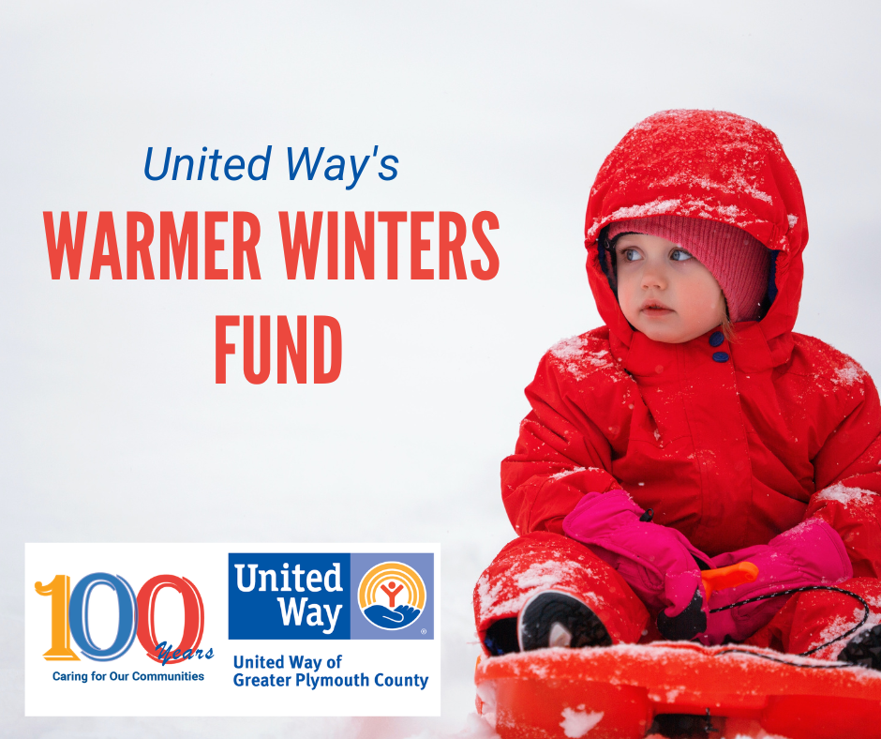
Costs for coats
has increased drastically!

More kids in need
than ever before!
We Need Your Help
Keeping Our Kids Warm This Winter
With New Coats!

United Way’s Annual Warmer Winters Fund has helped over 1,855 children in greater Plymouth County stay warm. With a challenging winter season around the corner and prices for everyday essentials increasing, we are looking to expand our fund and support more children. Donations will go directly to United Way’s Family Center and to United Way’s partner agencies to provide our youth with one of their most basic needs-- a toasty new winter coat to help them stay safe and continue on the path to a bright future.
Can you help us spread the warmth?
Consider making a gift in honor of someone in your life that has kept you warm.
Examples: a parent, a partner, or a friend who has inspired you, given you a jacket growing up, shared joy with you during difficult times, or simply gives you that “warm and fuzzy” feeling!
To donate, contact Lisa Maciejowski, Director of Resource Development at
508-583-6306 ext. 204 or lmaciejowski@uwgpc.org

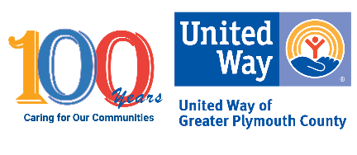
2022 Warmer Winters Sponsorship or Individual Donor Sign Up
Yes! Count us in! We want to help keep our neighbors warm this winter.
 100 Coats for Kids $5,500
   50 Coats for Kids $2,750
   25 Coats for Kids $1,375
   Coat Donation $55

Sponsorship/Donation Amount: _________________________________________________
 I would like to make a gift in honor of someone who has kept me warm.
Please display our name (including “in honor of” if applicable) as follows in the Warmer Winters promotional materials, press release and social media:
Payment Options: We respectfully request that payment of your sponsorship be made by November 14, 2022 so that we are able to provide our participating agencies with immediate financial assistance for the Warmer Winters campaign.

 Check Enclosed
 Credit Card – Visit www.uwgpc.org and click on “Donate”, then “Donate Online Here”. Please note “Warmer Winters” in the comment box. You may also scan the QR Code on your smart phone to go directly to the page.

Thank you for supporting United Way of Greater Plymouth County
Please fax or send completed form to: UWGPC 934 West Chestnut Street, Brockton, MA Fax: 508-584-0240 or
e-mail to Lisa at lmaciejowski@uwgpc.org
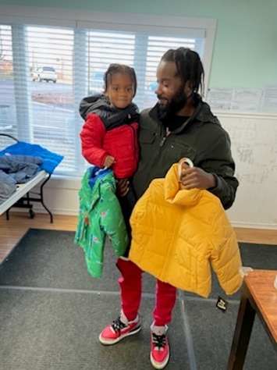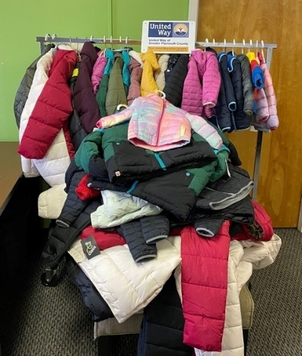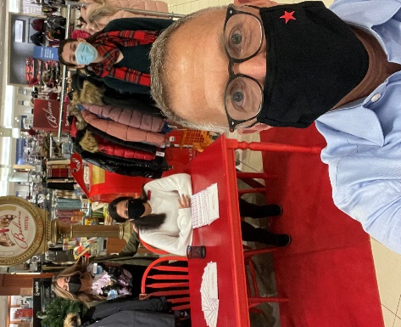
2021 Warmer Winters Photos

