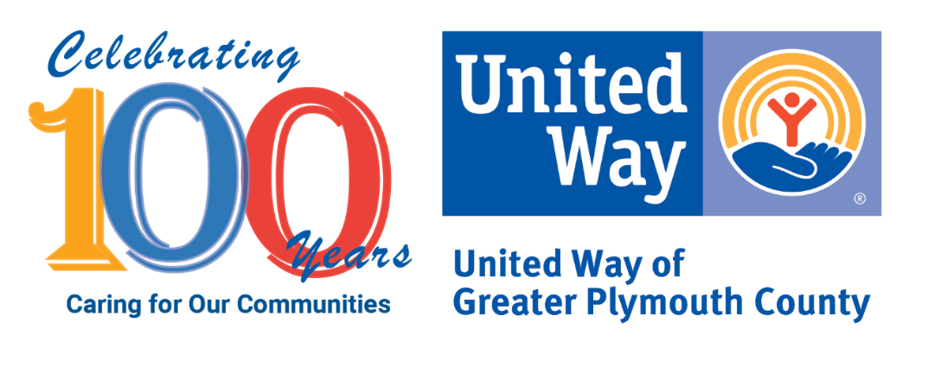
United Way of Greater Plymouth County’s
100th Anniversary Marketing Toolkit
Attachments (ZIP File):
- Anniversary Logo
- FY2021 Map of Individuals Served by Town
- 100th Anniversary Ways to Celebrate
- 100th Anniversary “The Difference Your Gift Makes” (Dollar Buy)
- Collective Impact Infographics “Change Won’t Happen Without You” Education
- Collective Impact Infographics “Change Won’t Happen Without You” Health
- Collective Impact Infographics “Change Won’t Happen Without You” Financial Stability
- UWGPC 21-22 One Pager
- United Way Family Center One Pager
- Pledge Form
- Resource: Mass 211 Flyer
- Resource: SingleCare (formerly FamilyWize) Prescription Savings Program FAQ Flyer
Key Message:
This year your local United Way is celebrating 100 years of caring for our communities. We celebrate YOU: our compassionate partners, our local businesses, our individual donors, our volunteers, and our friends for lifting up over 60,000 of our neighbors in need. Your leadership and generosity help local families and individuals get the support they need in the areas of education, health, and financial stability—the building blocks for a good life. Please continue to help us celebrate our mission to unite people, ideas, and resources to improve lives. Find out all the ways you can help your local United Way of Greater Plymouth County at uwgpc.org/100.
Social Media
Facebook: @uwgpc
Instagram: @uwgpc
Sample social media post: Congratulations to @uwgpc on celebrating 100 years of caring for our communities! XYZ Company is proud to support United Way of Greater Plymouth County. Last year, they served 60,000 of our neighbors in need. Together, we can build a stronger community. Help celebrate at uwgpc.org/100. #UWGPC100 #LIVEUNITED

