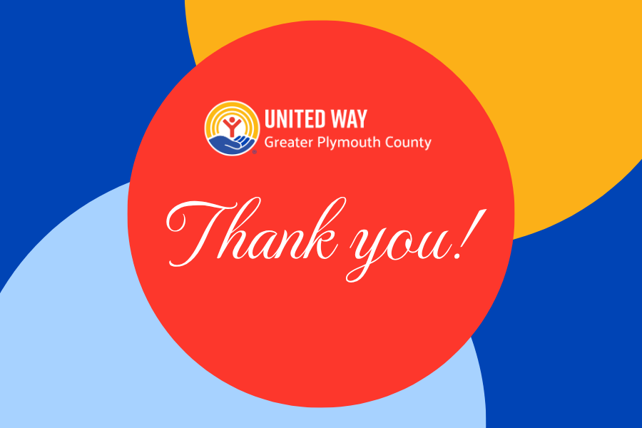

Thank you for your generous gift to United Way of Greater Plymouth County!
Your support is creating real change for individuals and families throughout our community. Because of your generosity, we're able to invest in programs that strengthen financial stability, improve health, support children and families, and connect neighbors with the resources they need to thrive.
Your gift helps make moments like these possible:
- A family receives healthy food during a difficult time.
- A child gains access to educational programs that prepare them for success.
- A parent receives financial coaching and resources to build a more secure future.
- A local nonprofit has the support it needs to serve our community year-round.

Every gift - no matter the size - helps build a stronger, more connected Greater Plymouth County.
Thank you for making a difference. We look forward to sharing the impact of your generosity throughout the coming year.

