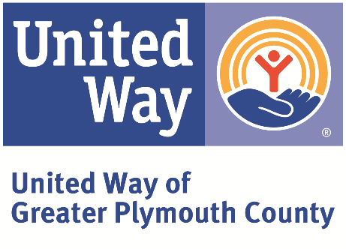

UNITED WAY OF GREATER PLYMOUTH COUNTY

Anti-Terrorism Compliance and Charitable Status

In compliance with the USA Patriot Act and other counterterrorism laws, United Way of Greater Plymouth County requires that each agency certify the following:

“I hereby certify on behalf of _______________________________ that all United Way funds and donations will be used in compliance with all applicable anti-terrorist financing and asset control laws, statutes, and executive orders.”

Print name: ___________________________ Title: _________________________

Signature: ____________________________ Date: _________________________

